TITLE |  | PAGE NO
Problem statement |  | 02
Scope of Requirements |  | 02
Roles and Responsibilities |  | 02
Functional Requirements |  | 03
Architecture Design |  | 04
Technology Stack |  | 04
Project approach and Methodology |  | 04
Deliverables |  | 05
Assumptions and Constraints |  | 05
Future Enhancement |  | 05
Conclusion |  | 05

PRESCRIPTO - ONLINE MEDICATION AND PRESCRIPTION TRACKING

Problem Statement
The Online Medication and Prescription Tracker is a web-based application designed to digitally manage prescriptions and medication schedules. The system aims to help users store prescriptions securely, track medication intake, and receive reminders, thereby improving medication adherence and reducing dependency on manual or paper-based methods.
In the current healthcare ecosystem, patients often rely on physical prescriptions and manual reminders, which are prone to loss, errors, and missed doses. Existing digital solutions either provide limited reminder functionality or lack centralized prescription management. This project addresses the need for a simple, secure, and user-friendly system to manage medications efficiently.
Scope of Requirements
The following features and functionalities are included within the scope of this project:
- User registration and secure login functionality
- Digital storage and management of prescriptions
- Ability to add, update, and delete medication details
- Medication scheduling with dosage and timing information
- Reminder notifications for medication intake
- Viewing medication history and active prescriptions
- Basic user profile management
- Secure storage of user and prescription data
- Role-based access for users (patient and caregiver/basic admin)
Roles & Responsibilities:
1.Patient
The patient is the primary user of the system and is responsible for managing personal medication and prescription information.
Responsibilities:
- Register and log in to the application
- View and manage personal profile details
- Upload or enter prescription information
- Receive and view medication reminders
- Track medication history
- View active and past prescriptions
2. Doctor
The doctor role is responsible for creating and managing prescription details for patients.
Responsibilities:
- Log in securely to the system
- Create and update digital prescriptions for patients
- Define medication dosage, frequency, and duration
- View patient prescription history
- Modify or discontinue prescribed medications
3. Administrator
The administrator oversees system usage and ensures correctness and quality of the application.
Responsibilities:
- Monitor application usage and data consistency
- Review system functionality and reports
- Manage user access and basic configuration
Functional Requirements
- User login and profile management
- Add, update, and delete prescription details
- Define medication dosage, frequency, and timing
- Generate reminders for scheduled medications
- View daily and weekly medication schedules

SYSTEM ARCHITECTURE:
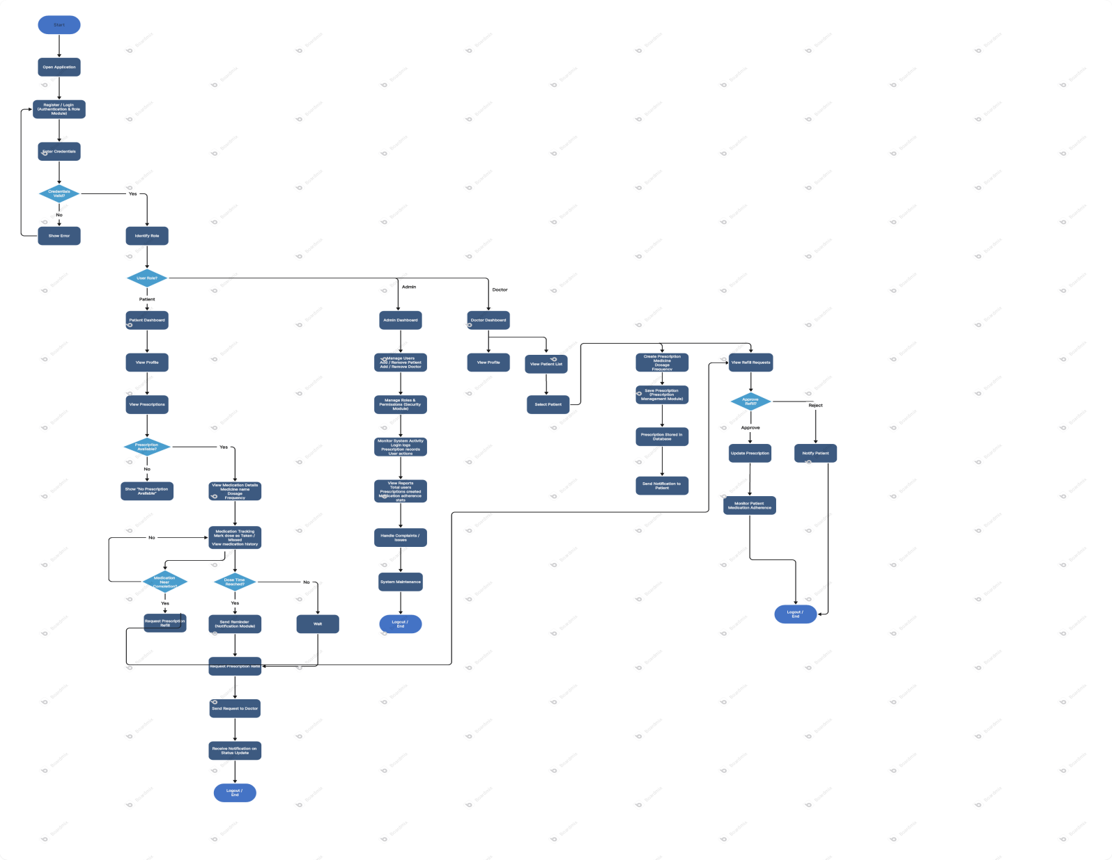
Technology Stack
- Frontend: HTML, CSS, JavaScript/ React js /angular
- Backend: Java 17, Spring Boot
- Database: MySQL
- Version Control: GitHub
- Development Tools: IntelliJ / Eclipse, Postman
Project Approach & Methodology
The project follows an Agile-inspired iterative approach, where functionality is developed incrementally and validated at each stage.
- Requirement analysis
- Design and architecture planning
- Module-wise development
- Testing and validation
- Documentation and review
Deliverables
- Functional web application
- Project documentation (DOCX)
- GitHub repository with code and documentation
- Final project demonstration
Assumptions & Constraints
- Users have access to internet-enabled devices
- Data entered by users is assumed to be accurate
- Project is developed within internship timelines
Future Enhancements
- SMS and voice-call reminders
- Mobile application support
- Doctor and pharmacy integration
- Multi-language support
- Advanced reporting and analytics
Conclusion
The Online Medication and Prescription Tracker is designed as a practical and scalable solution to address common medication management challenges. The current phase focuses on delivering a stable core system, while keeping scope open for future enhancements aligned with industry needs.

